**Project Report**

|  |  |
| --- | --- |
| **Product Name** | Advanced Certificate in Web Development |
| **Qualification Name (NICF)** | ITSF - Advanced Certificate in Information Technology (Application Development) |
| **Product Name** | Front End Web Development |
| **Module Name (NICF)** | ITSF - Front End Web Development |

|  |  |  |  |
| --- | --- | --- | --- |
| **Student name** | | **Assessor name** | |
| Wildan Luqmanul Hakim | | Ms. Anindita Bose, Mr. Rahul Raghubanshi | |
| **Date issued** | **Completion date** | | **Submitted on** |
| March 31, 2022 | May 10, 2022 | | May 10, 2022 |
|  | | | |
| **Project title** | **Development of website for a Training Organization** | | |

|  |
| --- |
| **Learner declaration** |
| I certify that the work submitted for this assignment is my own and research sources are fully acknowledged.    Student signature: Date: May 10, 2022 |

**Content**

1. Project background
2. Project Objectives
3. Requirement Specifications
4. Task 1
5. Task 2
6. Task 3
7. Task 4
8. Task 5
9. Task 6
10. Task 7
11. Task 8
12. Task 9
13. Task 10
14. Task 11
15. Task 12
16. Task 13
17. Task 14
18. Task 15
19. Task 16
20. Task 17
21. **Project Background**

Website is a medium used to accommodate text data, images, sounds, and animations that can be displayed on the internet and can be accessed by computers connected to the internet globally. Website is a computer network-based information media that can accessible anywhere at a relatively low cost.

in this case the ABC Learning Center makes a website-based learning that will make it easier for peoples to access it anytime and anywhere, ABC Learning Center provides various courses such as Learn Java, Learn Python, and many others. at ABC Learning Center you will get a cheap course price, and of course with a reliable mentor who is ready to help you.

The competition is so tight that ABC Learning center continues to move forward to be the best in technology-based learning courses.

# Project Objective

ABC Learning Center’s business goals:

* + Improve branding image
  + Increase the number of monthly qualified leads by 20%.
  + Make course helpful for customers
  + Make visitors fun with the course

ABC Learning Center’s website goals:

* + Easy to access and navigate to obtain latest information
  + Accessible 24/7
  + Making simple platform Lead generation

Tools & platform used

* + Figma for wireframe and storyboard design
  + Visual Studio Code for development
  + Microsoft Word for document
  + Microsoft Powerpoint for presentation
  + Following, but not limited to, browsers are used

1. Google Chrome

# Requirement Specification

## Scope

* + Display the content relevant to the courses
  + Lead Generation Form
  + Lead Administration

## Out of Scope

* + Integration with database
  + User administration – login, logout, user registration,
  + Search Engine Optimization
  + Backup site
  + Responsive page for administration

## Functional Requirements

Following features and pages should be available in the website.

1. Common Content
   1. Header

In the web page layout, the header is the upper (top) part of the webpage. It is definitely a strategic part of the page as the area which people see before scrolling the page in the first seconds of introduction to the website.

* 1. Footer

The section of content at the very bottom of a web page. It typically contains a copyright notice, link to a privacy and link to sitemap.

* 1. Navigation

The act of clicking and looking through resources on the internet, such as the various pages that make up a website

1. Home Page
2. About Us Page / Profile Page
3. Course Listing Page
   1. Learn Java
   2. Learn Python
   3. Learn .NET
   4. Learn Microsoft Office
4. Course Details Page
   1. Learn Java
   2. Learn Python
5. Course Schedule Page
   1. Learn Java Schedule
   2. Learn Python Shedule
6. Contact Us Page
7. Registration Course Page
   1. Full Name
   2. Email
   3. Contact Number
   4. Select Gender
   5. Select Course
8. Thank You Page
9. Lead Administration Page
   1. Add – to add new lead
   2. List – to list the leads
   3. Edit – to update the lead details
   4. Delete – to delete the leads
10. Sitemap Page
11. Privacy Policy Page

## Non-functional Requirements

1. Branding
   1. ABC Learning Center logo
   2. ABC Learning Center domain name as abc.com
   3. ABC Learning Center corporate color scheme
2. Following browsers but not limited to are to be supported.
   1. Google Chrome
   2. Microsoft Edge
   3. Mozilla Firefox
   4. Safari
   5. Opera
3. Website must be able to scale when traffic volume increase.
4. Website must be available 24/7 with at least 99.9% uptime.
5. Website pages must load within 3 seconds.
6. All data store must be secured.

## Technical Requirements

1. Software
   1. Web Server: Tomcat 9/Apache 2.4
   2. Editor: Visual Code Studio
   3. Browser: Google Chrome and All Browser
   4. Programming Languages: HTML, CSS, JavaScript, jQuery
   5. Operating System: Windows 10 and above. Mac 10.11 and above
2. Hardware
   1. CPU : Intel Core Pentium 4 or later
   2. RAM : 4 GB
   3. Screen Resolution : 1280x1024 or larger
   4. Harddisk : 10 GB Minimum

# Task 1

## Task Statement:

List and document features in a requirements specification document

Include sections for Website, Lead Generation form and its Administration.

Include it as part of the Project Report

## Solution:

**Scope**

* + Display the content relevant to the courses
  + Lead Generation Form
  + Lead Administration

## Out of Scope

* + Integration with database
  + User administration – login, logout, user registration, reset password
  + Search Engine Optimization
  + Backup site
  + Responsive page for administration

## Functional Requirements

Following features and pages should be available in the website.

1. Common Content
2. Header
3. Footer
4. Navigation
5. Home Page
6. About Us Page / Profile Page
7. Course Listing Page
8. Learn Java
9. Learn Python
10. Learn .NET
11. Learn Microsoft Office
12. Course Details Page
13. Learn Java
14. Learn Python
15. Course Schedule Page
16. Learn Java Schedule
17. Learn Python Shedule
18. Contact Us Page
19. Registration Course Page
20. Full Name
21. Email
22. Contact Number
23. Select Gender
24. Select Course
25. Thank You Page
26. Lead Administration Page
27. Add – to add new lead
28. List – to list the leads
29. Edit – to update the lead details
30. Delete – to delete the leads
31. Sitemap Page
32. Privacy Policy Page

## Non-functional Requirements

1. Branding
   1. ABC Learning Center logo
   2. ABC Learning Center domain name as abc.com
   3. ABC Learning Center corporate color scheme
2. Following browsers but not limited to are to be supported.
   1. Google Chrome
   2. Microsoft Edge
   3. Mozilla Firefox
   4. Safari
   5. Opera
3. Website must be able to scale when traffic volume increase.
4. Website must be available 24/7 with at least 99.9% uptime.
5. Website pages must load within 3 seconds.
6. All data store must be secured.

## Technical Requirements

1. Software
   1. Web Server: Tomcat 9/Apache 2.4
   2. Editor: Visual Code Studio
   3. Browser: Google Chrome and All Browser
   4. Programming Languages: HTML, CSS, JavaScript, jQuery
   5. Operating System: Windows 10 and above. Mac 10.11 and above
2. Hardware
   1. CPU : Intel Core Pentium 4 or later
   2. RAM : 4 GB
   3. Screen Resolution : 1280x1024 or larger
   4. Harddisk : 10 GB Minimum

# Task 2

## Task Statement:

1. Create an Information Architecture & Storyboard for the website
2. Propose the Information flow for a Leads generation form & Its Administration (Login Not Required)
   1. User must be able to Add, Edit, Delete & List leads
3. Include it as part of Project Presentation

## Solution:

This section is documented in the Project Presentation.

# Task 3

## Task Statement:

1. Develop the HTML Pages required for the website
2. Develop the Lead Generation Form & Administration System pages for Lead Generation form Management
3. Include the screen capture as part of Project Presentation

## Solution:

The HTML pages are documented in the Project Presentation.

# Task 4

## Task Statement:

1. Propose & use jQuery Components such as the menu, popup, etc as part of the website.
2. Design the required HTML for jQuery Components
3. Provide screen capture as part of Project Presentation

## Solution:

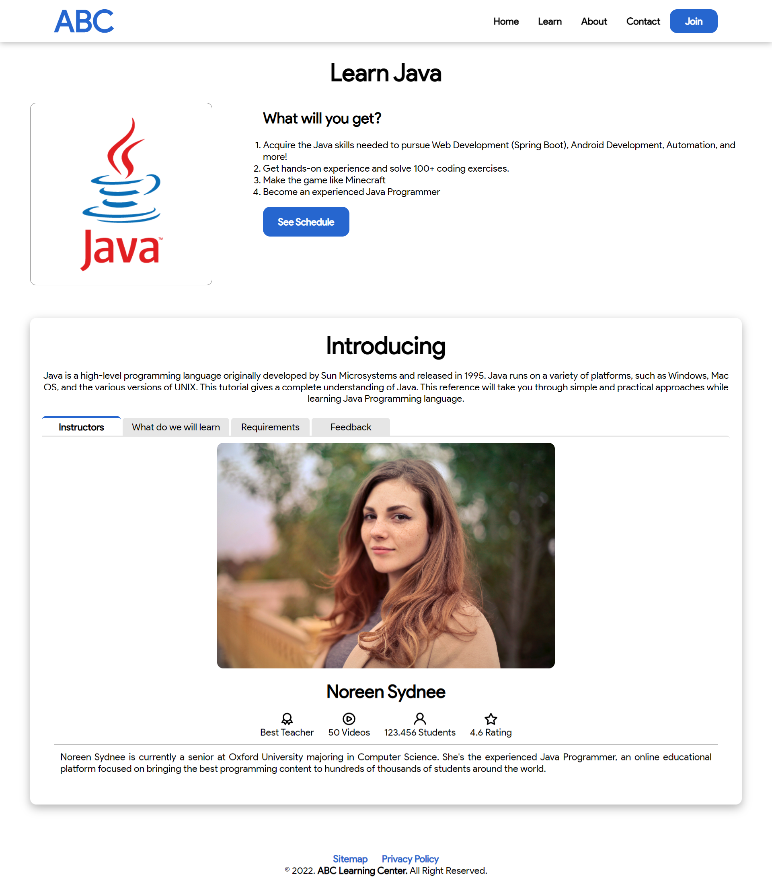. 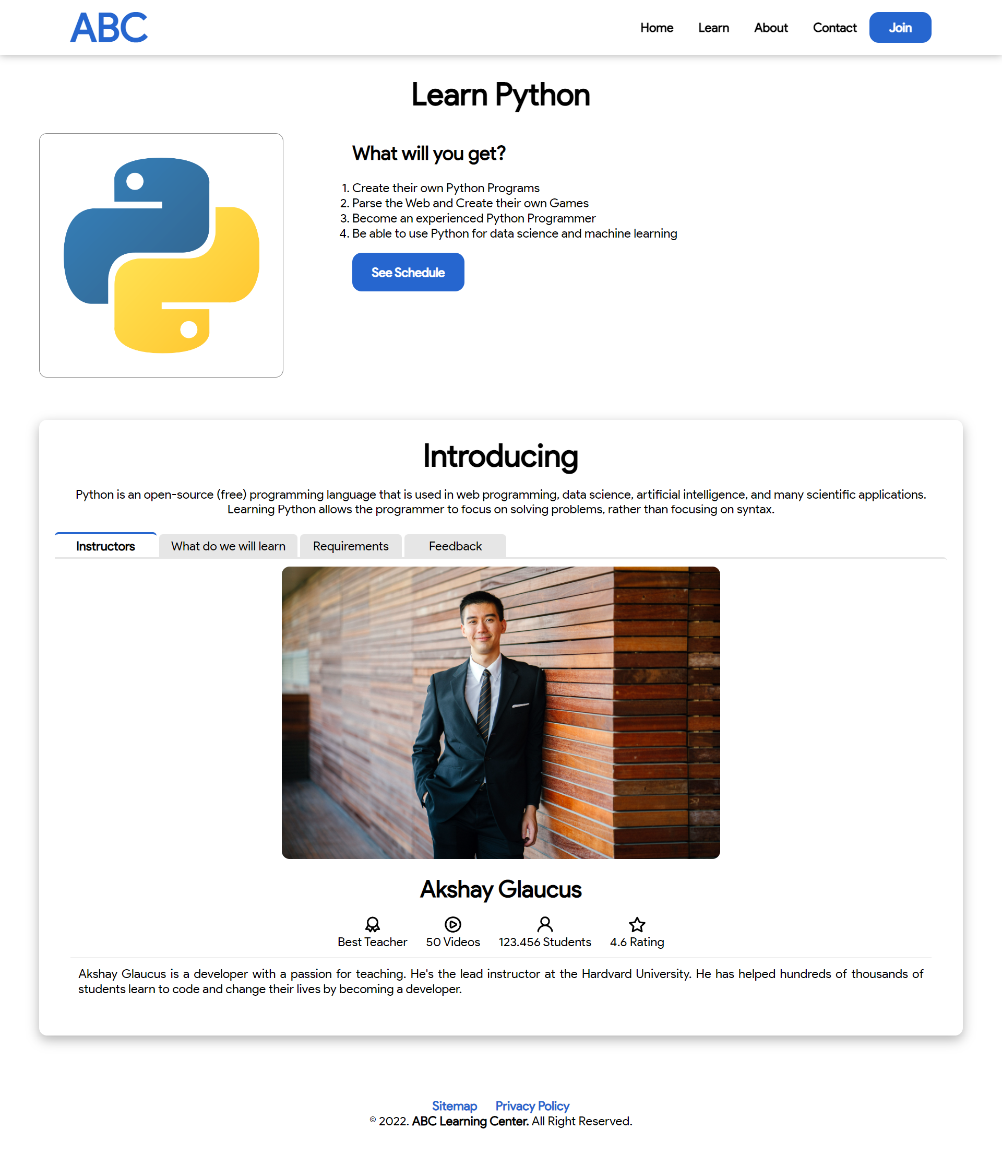

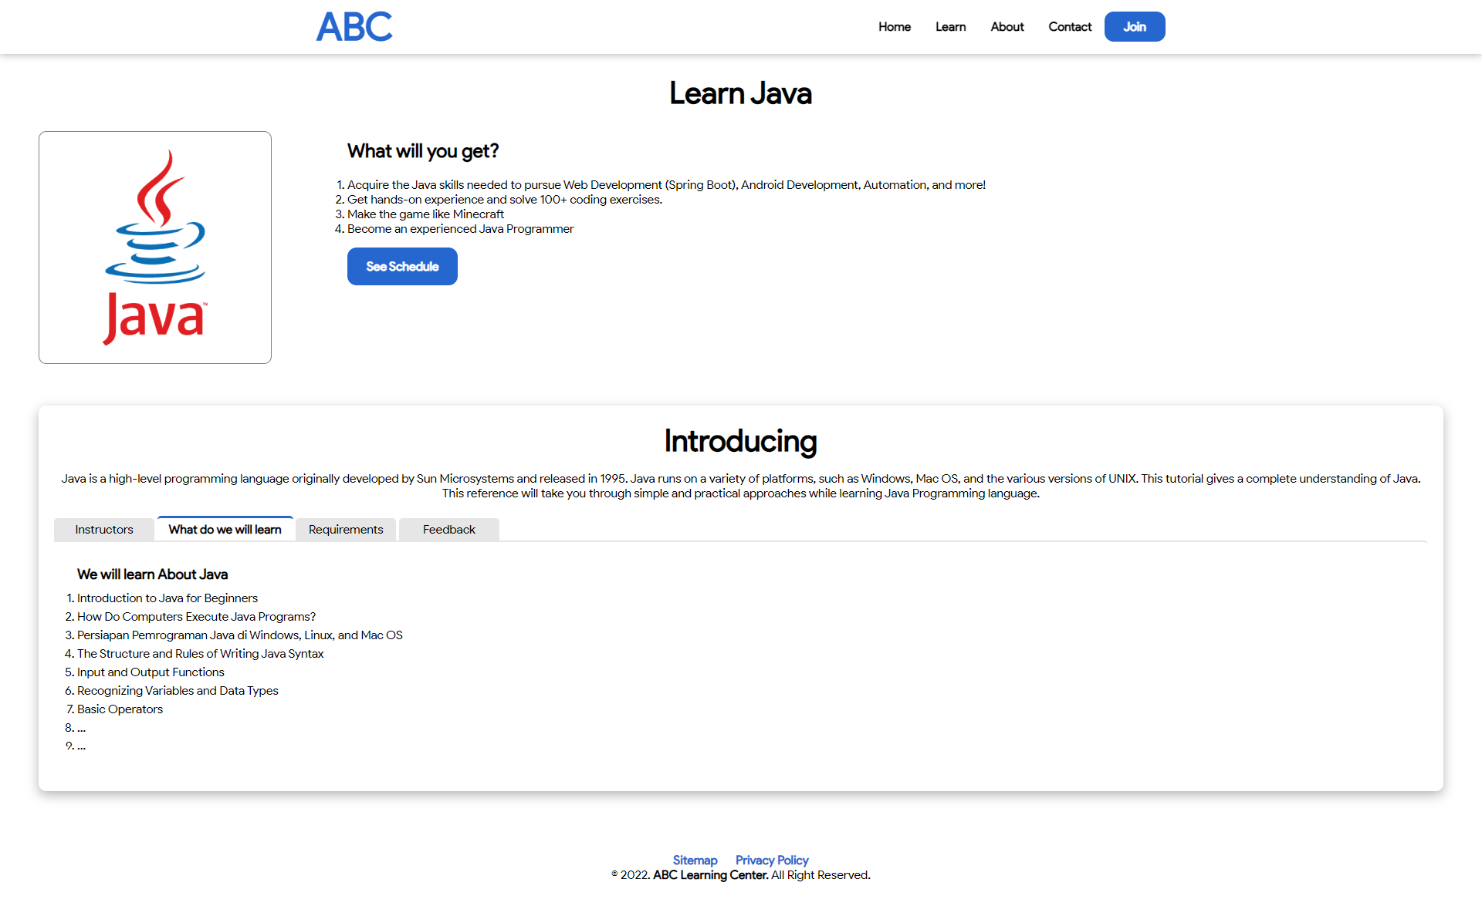 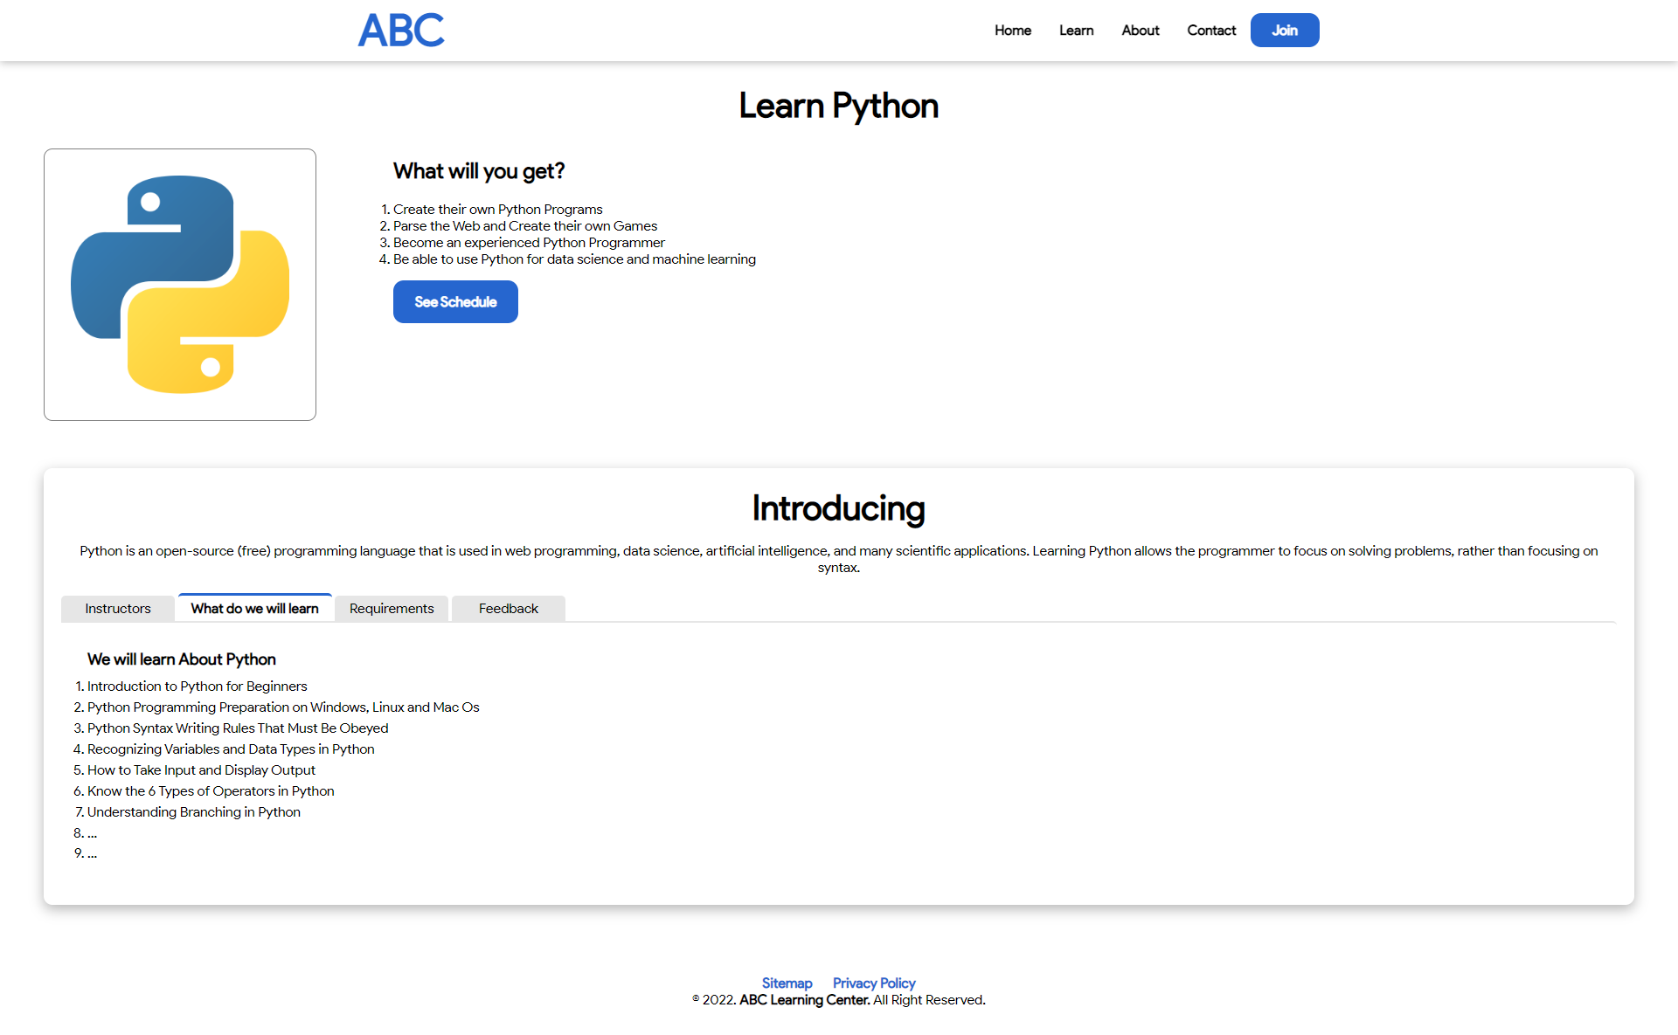

|  |  |
| --- | --- |
| Menu Bar Java Course | Menu Bar Python Course |

# Task 5

## Task Statement:

1. Write a paragraph on the effectiveness of the designed Lead Generation Administration System
2. Write briefly on effectiveness of the User Interface according to 2 metrics
3. Include it as part of Project Report

## Solution:

Lead generation is a powerful tool for promoting or advertising products or services. Lead generation is a technique for attracting potential customers and guiding or showing them your products or services in a unique and interesting manner. ABC Learning Center's target customers in this case are those with an interest in the field of information technology. To attract potential customers, ABC Learning Center will use their website to promote and showcase their products/offers, such as showing the benefits of applying for the courses, showing what they will learn, showing the company's origins, privacy policy, and each course schedule and subjects.

The most important part of a website's landing page is to entice a potential customer (visitor) to stay and look at the products or services on offer. With its new website, the ABC Learning Center will include "call-to-action" features or a display image that will pique the visitor's interest and curiosity. If a visitor stays on the website and browses around, they can fill out the "registration form" on the home page, which is marked with "Read More Button".

When a visitor submits a registration form, the ABC Learning Center staff is able to view the information immediately and will contact the visitor for further coordination or arrangements.

## Metrics for Lead Generation Form

* Filling out the Registration Form should take no longer than 2 minutes.
* To prevent unwanted data or errors, the registration form includes a validation feature.
* For easy access, the registration button is located on the home page.
* Easy To Use

The website will be able to use the feature without facing any trouble and difficulty. The form is simple, so the visitor can fill the form quickly. The Administration system is easy-to-use because it doesn’t need any technical skill to operate. It just needs a mouse and keyboard to click the button and fill out the form.

* Code Efficiency

The code must be easy to read and maintainable. Even though it needs a complex data structure, it must be clean. The design should not be too complex because it will cause trouble in a run time performance issues. Keep the business logic as simple as possible to optimize the run time.

* Overall

All of the above things will make the Lead Generation Form more effective to increase the lead conversion more complete and accurate lead information. And then, these things make the admin of ABC Learning Center doesn’t need to do an unnecessary things to revalidate the data of the lead.

# Task 6

## Task Statement:

1. Make changes to User Interface based on effectiveness metrics identified in Task 5
2. Make the changes to HTML, CSS & Javascript
3. Include the screen capture along with list of modifications made as part of the Project Presentation

## Solution:

This is discussed in the Project Presentation.

# Task 7

## Task Statement:

Create a User Guide for Lead Generation form and its Associated Administration Module

## Solution:

**Lead Generation Form**

* 1. At the Home page, click on the “See More” side of Laptop Picture

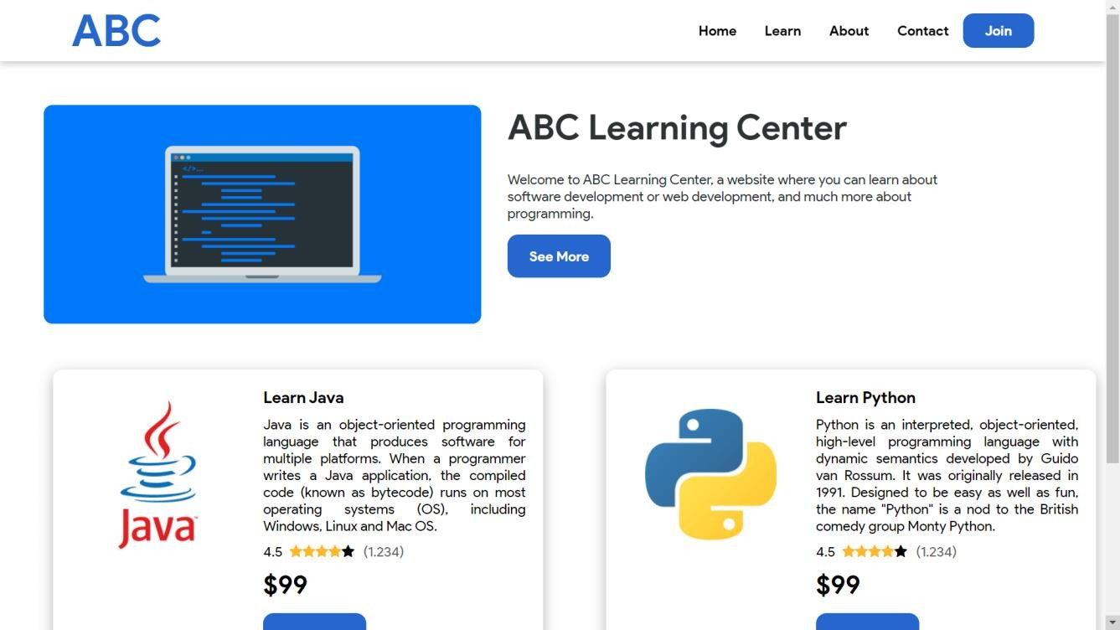

* 1. You will be redirected to Course Registration Page

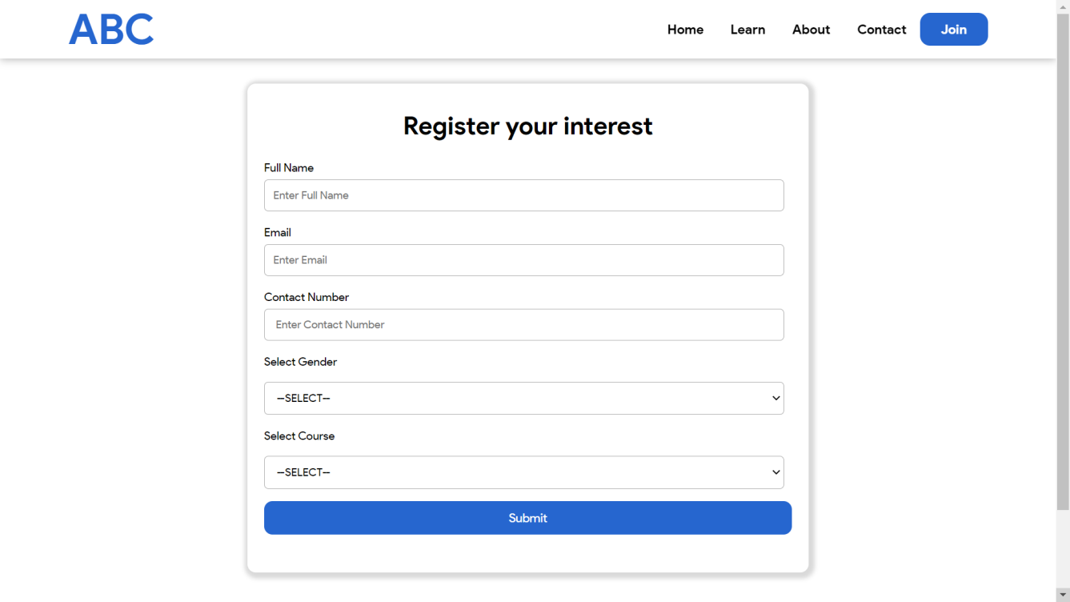

* 1. Fill up the form to input the followings.
     1. Enter the full name
     2. Enter the email
     3. Enter the contact number
     4. Select the gender
     5. Select the course
  2. Click ‘Submit’ button to submit the form into the system.

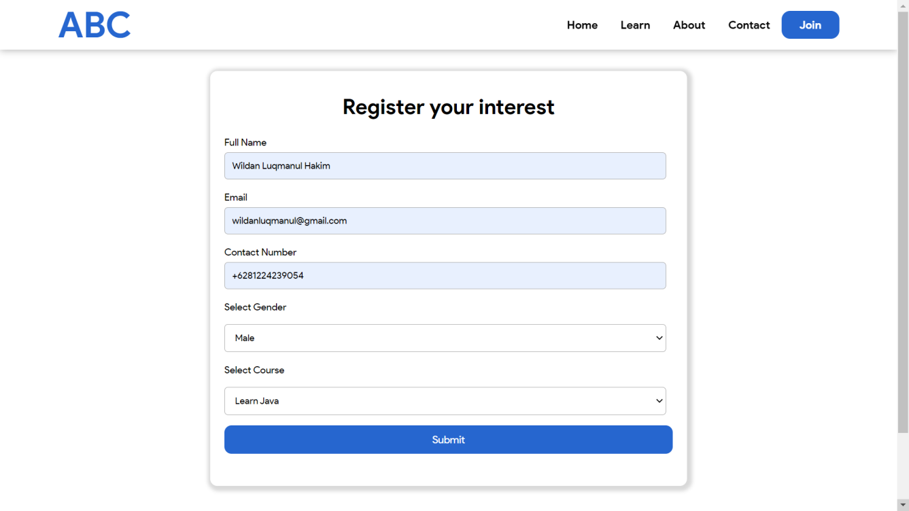

* 1. Upon submission, validation of fields will be done. If there’s any mistake, a guide will be displayed as shown below.

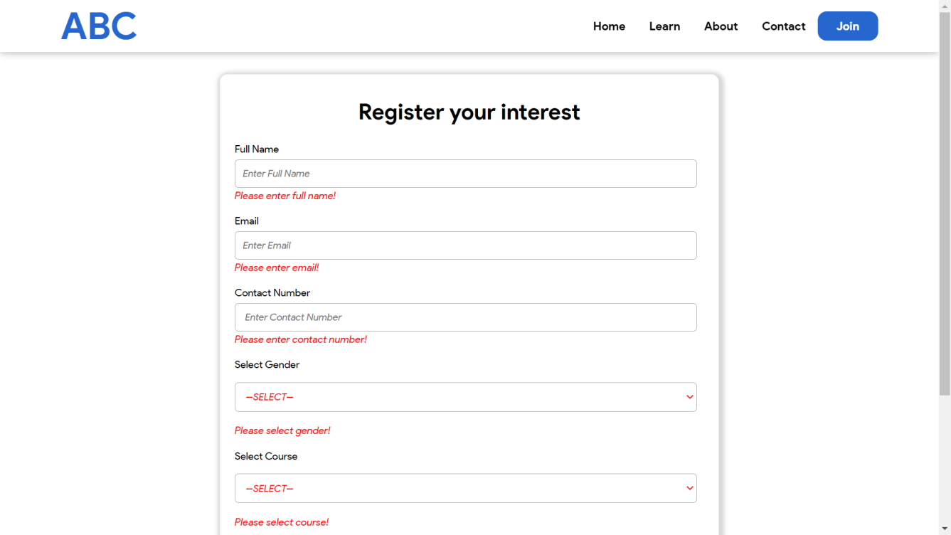

* 1. If all entries are validated correct, You will be redirected to Thank You Page as shown below.

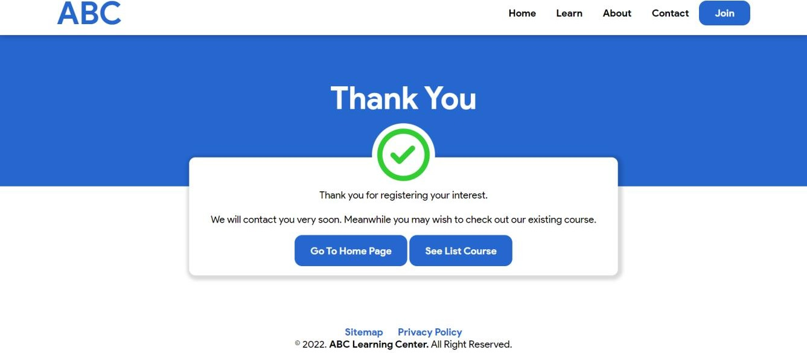

## Lead Administration System Leads Listing Page

**Add Lead**

1. 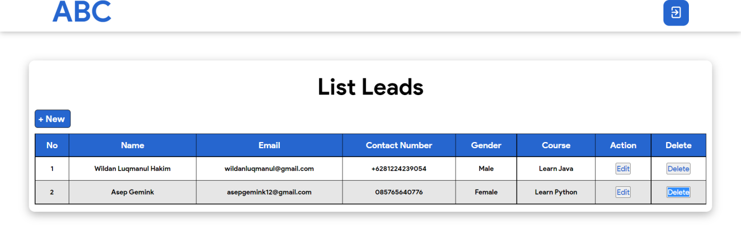Click on the “+New”
2. A pop-up form will be displayed as shown below.

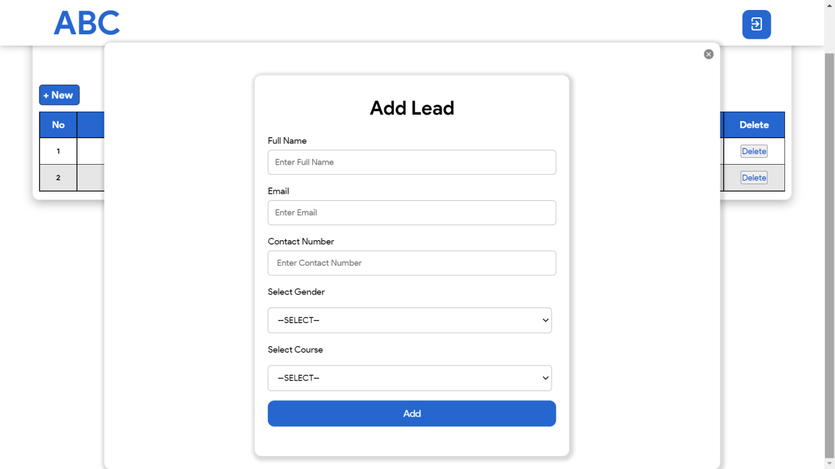

1. Fill up the form to input the followings.
   1. Enter the full name
   2. Enter the email
   3. Enter the contact number
   4. Select the gender
   5. Select the course

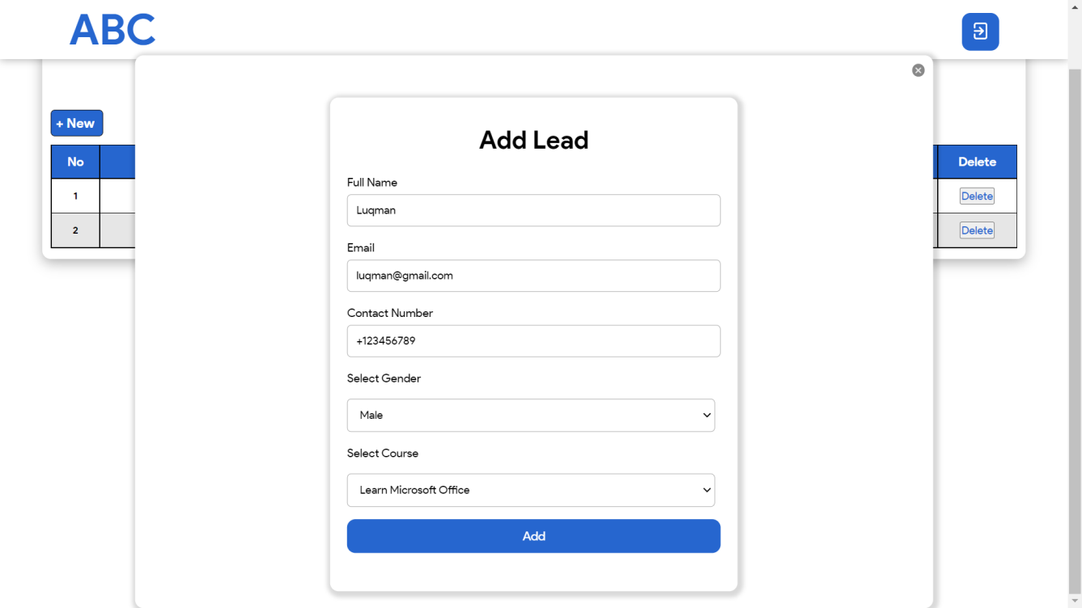

1. Click ‘Add’ button to create the new lead into the system.
2. Validation of fields will be done. If there’s any mistake, a guide will be displayed as shown below.

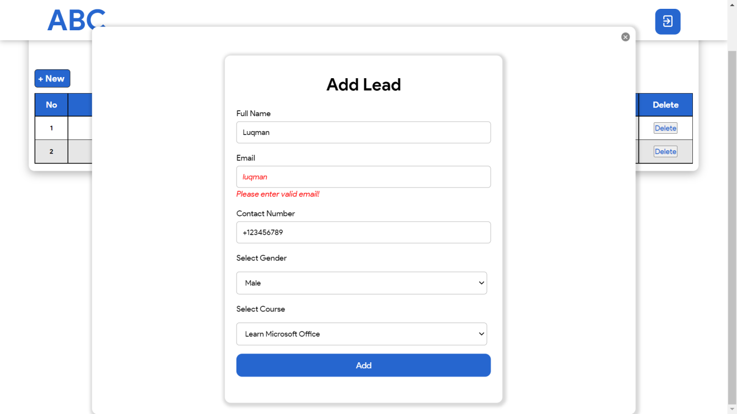

1. Click ‘close button’ at the top right to cancel the creation of the lead.

## Edit Lead

1. Click on the ‘Edit’ of row
2. A pop-up form will be displayed as shown below.

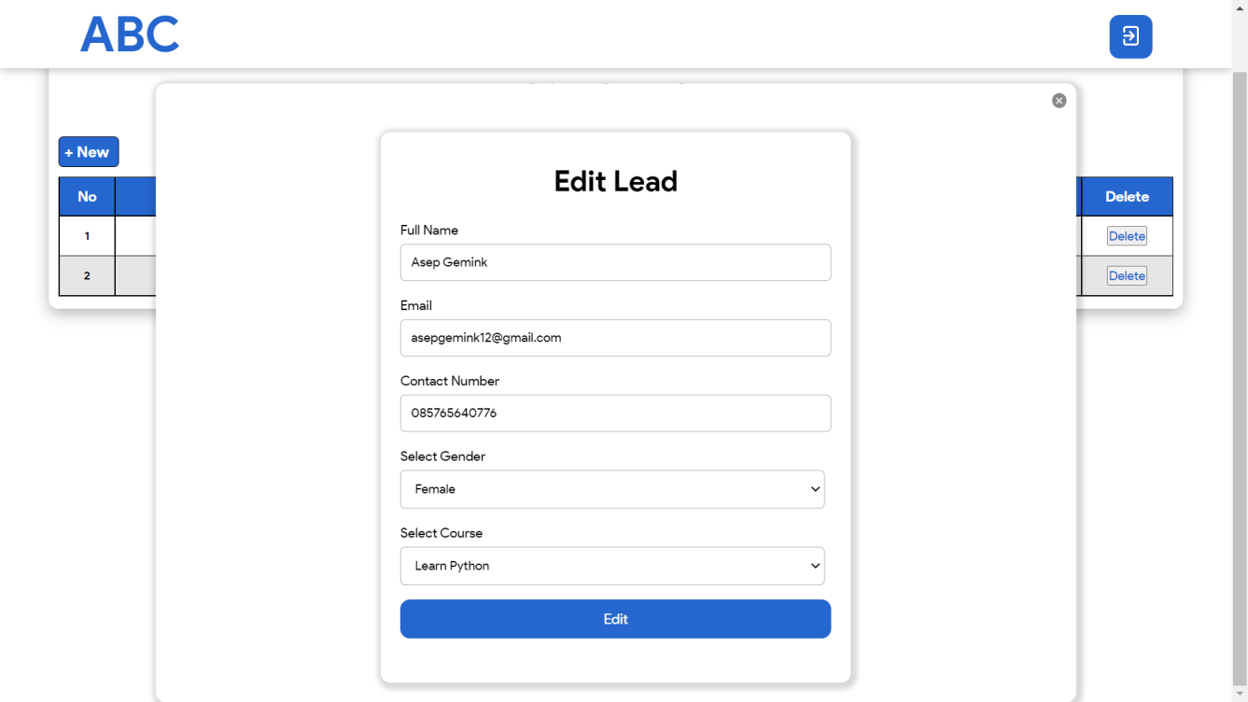

1. Make the required changes accordingly.
2. Click ‘Edit’ button to update the lead into the system.
3. Validation of fields will be done. If there’s any mistake, a guide will be displayed as shown below.

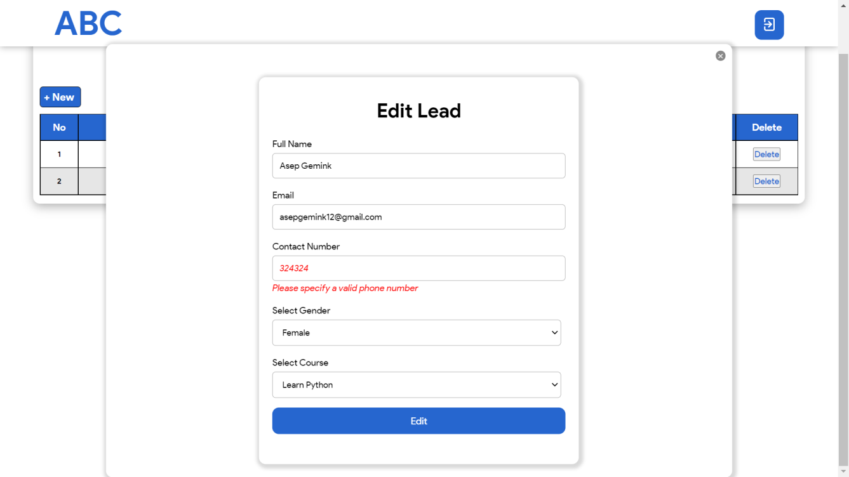

1. Click ‘close button’ at the top right to cancel the modification of the lead.

## Delete Lead

1. Click on the ‘Delete’ of row of the lead to remove.